|  |  |  |  |
| --- | --- | --- | --- |
| Year 11 – Latent Heat of Ice Experiment | | | |
|  | | | |
| **Name:** | **Teacher:** | **Score /** | |
| **Comment:** | | | **Due Date:** |

25% of your grade will be on the pre-lab [25 marks]

25% of your grade on laboratory results and answering questions

50% on validation test

The AIM of this experiment is to determine the LATENT HEAT OF ICE

1. Explain what is meant by the term “Internal Energy”. [ 2 marks]

|  |
| --- |
|  |
|  |

1. In the space below sketch the temperature curve that you would expect to see if you graphed the temperature vs. time for solid ice as it was heated from -10˚C to melting, then to boiling point and then onwards to 120 ˚C. Label all parts of the graph. [ 5 marks]
2. What happens to temperature in the places that a phase change is occurring? [ 1 mark]

|  |
| --- |
|  |
|  |

1. If Heat Energy is still being supplied to the substance during a phase change where does this energy go? [ 1 mark]

|  |
| --- |
|  |
|  |

1. Look up and write a definition for the term “latent” as it is used in an everyday (i.e. non Physics sense). [ 1 mark]

|  |
| --- |
|  |
|  |

6 Provide a definition for “latent heat” in a Physics sense. [ 2 marks ]

|  |
| --- |
|  |
|  |

1. Look up the values for the latent heat of **fusion** (Freezing/melting) and latent heat of **Vaporisation** (evaporation/condensation) and write them below, stating the units [ 2 marks]

|  |
| --- |
|  |
|  |

1. Which has the lowest value? How will this affect the lengths of the lines you sketched in question 2? [ 2marks]

|  |
| --- |
|  |
|  |

1. Compare the latent heat values to the specific heat values, what do you notice? [ 1 mark]

|  |
| --- |
|  |
|  |

*Read the method given for the experiment and answer the following questions.*

1. Explain why copper is a good material to make a calorimeter from. [ 2 marks]

|  |
| --- |
|  |
|  |

1. Why do you think it is important that the ice is dried with a paper towel before it is added to the water in the calorimeter? [ 1 mark]

|  |
| --- |
|  |
|  |
|  |

1. The ice gains heat in this experiment, first melting and then warming until it reaches an equilibrium temperature with the water in the calorimeter. Write an equation show the total heat gained by the ice. [ 2 marks]

|  |
| --- |
| Total Heat GAINED = ffff |
|  |
|  |

1. In the equation you have written for the heating of the ice, which is the more appropriate specific heat, water or ice? Explain. [ 1 mark]

|  |
| --- |
|  |
|  |

1. Write an equation show the total heat lost by the water and calorimeter. [ 2 marks]

|  |
| --- |
| Total Heat LOST = ffff |
|  |

*Read the experiment again. On a separate sheet of paper, write the aim and prepare a suitable table to record your results in. Have this ready before the date of the assessment. Ensure you fully understand the experiment before the date of the assessment.*

**Aim: To Determine the latent heat of fusion of ice.**

**Apparatus**

* copper calorimeter with insulating Styrofoam cap
* insulated container for the calorimeter ice (a few cubes)
* Digital thermometer
* warm water (about 35 °C)
* blotting paper or paper towel

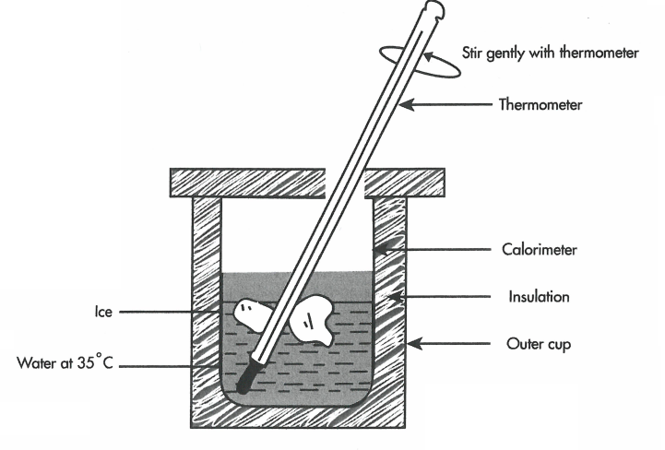**Lab Procedure**

1. Measure and record the mass of the empty calorimeter.
2. Fill the copper calorimeter about two-thirds full of water at about 35 °C, and then measure the mass of the calorimeter and water. Hence determine the mass of water in the calorimeter.
3. Place the calorimeter into the insulated container. Stir gently with thermometer.
4. Measure the temperature of the water in the calorimeter. This will also be the temperature of the calorimeter itself. Take temperature readings to the nearest 0.2 °C.
5. Wipe a small cube of ice with a paper towel to remove any moisture adhering to it.
6. Crush the ice cube to obtain small lumps. Carefully place the dried crushed ice into the calorimeter, avoiding splashing the contents. Place the insulating cap on the calorimeter.
7. Gently stir the mixture until the ice has melted.
8. Continue to add small pieces of ice in the same way until the temperature falls to about 5 °C. Record the final temperature.
9. Find the mass of the calorimeter and its contents and hence determine the mass of ice added.
10. Repeat to obtain a second set of results.

**Processing Results and Post Lab Questions**

1. Calculate the total heat lost by the calorimeter itself, and the warm water in the calorimeter, as it cools to the final temperature, Tf. This heat melts the ice and then raises the temperature of the resulting water.
2. If you assume that the amount of heat lost to the surroundings is insignificant, then the total heat gained will be equal to the total heat lost.

**Hence, calculate the latent heat of fusion of the ice (Lf).**

1. The water from which the ice cubes were produced probably contained certain impurities, such as soluble salts and dissolved gases.
2. How is this likely to affect the ice cubes?
3. What assumption made in this experiment is most likely to be affected by these impurities in the water?
4. What effect would these impurities have on the value you determined for the latent heat of fusion of ice?
5. Why was it desirable to start with the calorimeter and water above room temperature?
6. Look up the ‘accepted’ value for the latent heat of fusion of ice. Compare your result with this figure and comment on any differences. Calculate a “percentage error” by comparing the difference between your result and the accepted value with the accepted value.
7. Why are ice packs at 0 °C better for cooling a sprained ankle than similar-sized packs containing water at 0 °C?